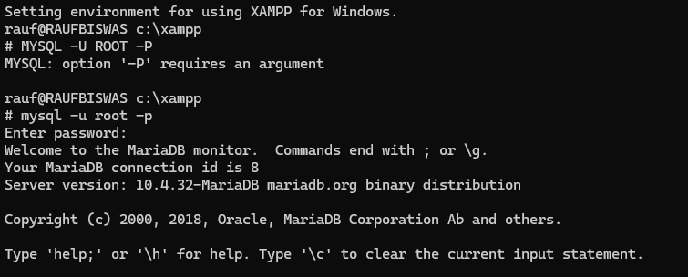

**Command:**

1. mysql -u root -p
2. SHOW DATABASES;
3. CREATE DATABASE CSE370;
4. USE CSE370;
5. CREATE TABLE Developers

(

member_id int,

name varchar(50),

email varchar(320),

influence_count int,

Joining_date date,

multiplier int

);

1. DESCRIBE Developers;
2. INSERT INTO Developers VALUES

(1, 'Taylor Otwell', 'otwell@laravel.com', 739360, '2020-06-10', 10),

(2, 'Ryan Dahl', 'ryan@nodejs.org', 633632, '2020-04-22', 10),

(3, 'Brendan Eich', 'eich@javascript.com', 939570, '2020-05-07', 8),

(4, 'Evan You', 'you@vuejs.org', 982630, '2020-06-11', 7),

(5, 'Rasmus Lerdorf', 'lerdorf@php.net', 937927, '2020-06-03', 8),

(6, 'Guido van Rossum', 'guido@python.org', 968827, '2020-07-18', 19),

(7, 'Adrian Holovaty', 'adrian@djangoproject.com', 570724, '2020-05-07', 5),

(8, 'Simon Willison', 'simon@djangoproject.com', 864615, '2020-04-30', 4),

(9, 'James Gosling', 'james@java.com', 719491, '2020-05-18', 5),

(10, 'Rod Johnson', 'rod@spring.io', 601744, '2020-05-18', 7),

(11, 'Satoshi Nakamoto', 'nakamoto@blockchain.com', 630488, '2020-05-10', 10);

1. SELECT * FROM Developers;

**Answer of the queries:**

1. SELECT * FROM Developers;

1. ALTER TABLE Developers CHANGE influence_count followers int;

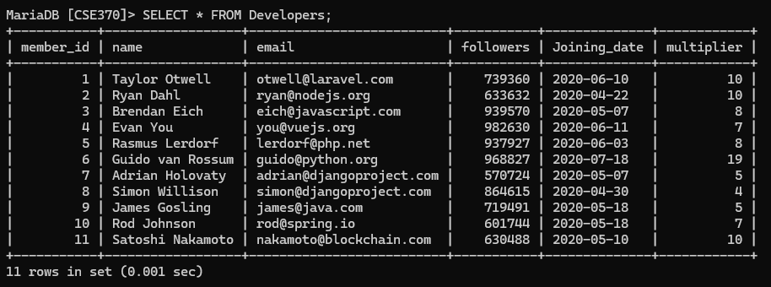

1. UPDATE Developers SET followers = followers + 10;

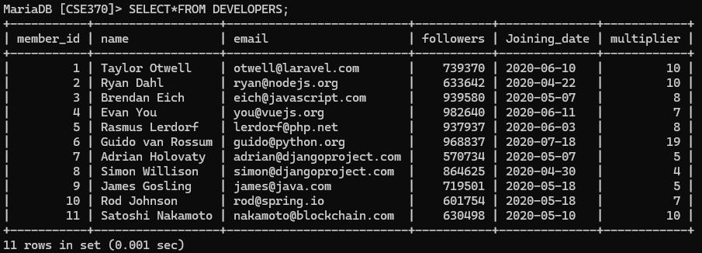

1. SELECT name, (followers * 100 / 1000000 * multiplier * 100 / 20) / 100 AS Efficiency FROM Developers;

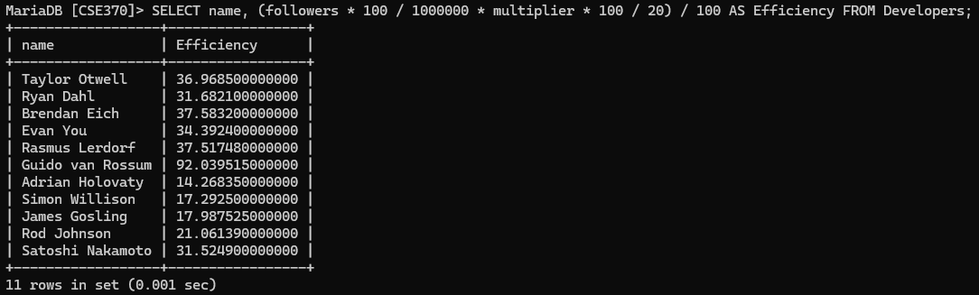

1. SELECT UPPER(name) AS name, Joining_date FROM Developers ORDER BY Joining_date DESC;

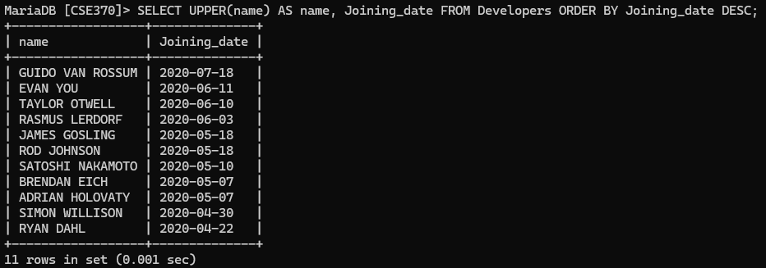

1. SELECT member_id, name, email, followers FROM Developers WHERE email LIKE '%.com%' OR email LIKE '%.net%';

